

50 Broad Street Bedford, NS B4A 0T4
902-405-0337, wbs@hrce.ca
Principal: Susan Casey Vice Principals: Jacinta Heckman
: Joanne Treen
Monday, November 3, 2025

Hello WBS Families,
Welcome to November! It's hard to believe that we've already completed 8 weeks of the school year. Our students have done an amazing job settling into their routines and embracing the expectations in both the classroom and the school community. We're looking forward to a wonderful month ahead!
Thank you for your ongoing support! Here's to a great November filled with learning, growth, and community spirit.
Warm regards,
Susan Casey, Principal

WBS November Highlights
School Liaison Officer Presentations
This month, we are excited to welcome our School Liaison Officer, Constable Andrew Paquet, who will be delivering important presentations across various grade levels:
- Stranger Danger for Primary and Grade 1 students
- Being a Good Digital Citizen for Grades 2 and 3
- Internet Safety and Cyber Bullying for Grades 4-6
These sessions are a valuable part of our commitment to keeping our students safe and informed.

Lunchtime Clubs and Intramurals
Our lunchtime clubs and intramural activities are in full swing! These extracurricular opportunities provide students with a chance to explore new interests and build skills outside of the classroom. We want to extend a special thank you to our dedicated staff members who volunteer their time to support these activities.

Important Dates and Announcements
WBS Spirit Wear
Last Day to Order: November 3rd
Our school clothing is now available for purchase. Orders and payments are processed directly through the clothing company, and items will be delivered to the school to be sent home with students. Happy shopping! Order Spirit Wear Here

Picture Day Re-takes and Class Photos
- Picture Re-takes: Tuesday, December 2, 2025
- Class Photos:
  - Grades Pre-Primary to 3: Tuesday, December 2, 2025
  - Grades 4-6: Wednesday, December 3, 2025

Home and School Association (HSA)
The next Home & School meeting is scheduled for Tuesday, November 18, 2025 from 6:00–7:00 pm in the seminar room.

School Advisory Council (SAC)
The next SAC meeting will also take place on Tuesday, November 18, 2025 from 7:00–8:00 pm in the seminar room.

2025-2026 Yearbooks
Yearbooks are now on sale for $40. Pre-order yours today! Order Your Yearbook Here

November News Beyond WBS

 November 8 - Indigenous Veterans Day
Indigenous Veterans Day is a time to honour the contributions and sacrifices of First Nations, Inuit, and Métis peoples who have served in the Canadian Armed Forces. In our schools, we aim to educate students about the significant role Indigenous veterans have played in defending Canada, fostering respect, reconciliation, and a deeper understanding of Canadian history.
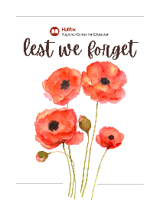 November 11 - Remembrance Day
Remembrance Day is an important occasion for students to reflect on the sacrifices made by veterans and those who have served in times of conflict. Through assemblies and creative projects, we emphasize the values of peace, tolerance, and gratitude for the freedoms we enjoy in Canada.
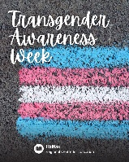 November 13-19 - Transgender Awareness Week
Transgender Awareness Week provides an opportunity to strengthen understanding and inclusivity for the transgender community, promoting safe and supportive environments for all students. Click here for more information.

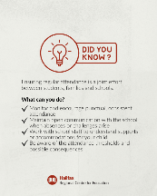 Attendance and Engagement Policy
Did You Know?
The Student Attendance and Engagement Policy emphasizes that regular, punctual attendance supports academic success and prepares students for the future. It is a shared responsibility between students, families, and schools.
What Should You Know?
- Attendance Monitoring: Schools track attendance and lateness. Absences must be communicated according to the school’s procedure.
- Absenteeism Intervention: If absenteeism reaches 10% of class time, the school will reach out to families for support. More targeted interventions may follow if absenteeism exceeds 15%.
- High School Credit Requirement: For Grades 10–12, students must attend at least 80% of class time to earn credits.
What Can You Do?
- Encourage consistent, punctual attendance.
- Stay in communication with the school when your child is absent.
- Work with school staff if supports or accommodations are needed.
- Be aware of attendance thresholds (10%, 15%) and the potential consequences (interventions, loss of credit in high school).

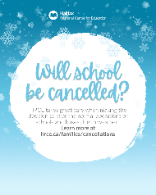 Planning for Inclement Weather
HRCE makes every effort to ensure clear communication regarding school closures or delays in the event of severe weather.
How Will I Find Out?
- Email notifications via PowerSchool
- Text messages (if opted-in: text Y to 978338)
- HRCE website and Instagram
Important Weather Protocols:
- School delays, closures, and early dismissals will be communicated by 6:00 am or 11:00 am, depending on the weather forecast.
- Please always have a childcare plan in place in case of weather-related closures.
For more information, visit HRCE Cancellation Page.

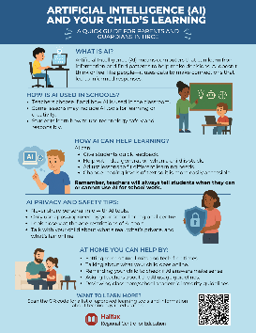 AI and Your Child's Learning
HRCE teachers and staff are introducing students to artificial intelligence (AI) in safe and meaningful ways that build awareness, creativity, and critical thinking. Together, we can help our learners understand how to use AI responsibly and confidently in their education and everyday lives. This informational sheet provides you with starting points for conversations about AI and learning AI Info Sheet

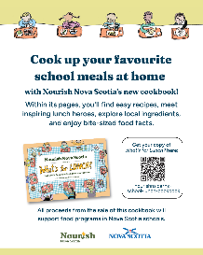 Hungry for Something Fun?
Check out the Nova Scotia School Lunch Cookbook — What’s for Lunch? Nova Scotia Recipes to Cook and Enjoy Together. This cookbook features delicious, easy-to-follow recipes and highlights the importance of healthy eating programs in our schools. Proceeds from sales go to supporting these programs.
Learn more and order your copy here.

Upcoming Dates
November
- Monday, November 10: Remembrance Day Assembly (outdoor, whole-school event)
- Tuesday, November 11: Remembrance Day (No School, PP-12)
- Wednesday, November 12: Remembrance Day Assembly (Weather Date)
- Friday, November 21: Assessment & Evaluation Day (No Classes for Elementary/Middle/Junior High)
December
- Tuesday, December 2: WBS P-6 Report Cards sent home
- Thursday, December 4: Professional Learning Morning / Family-Teacher Meetings (1:00-3:30 pm & 5:30-7:30 pm)
- December 8-12: Special Events Week (Scholastic Book Fair, Band, Choir, Ukulele Performances, and Fine Arts Events)
(Please note that this special events week is in lieu of a holiday concert)
- December 19: Final day of school for Students
School re-opens Monday, January 5th ,2026

