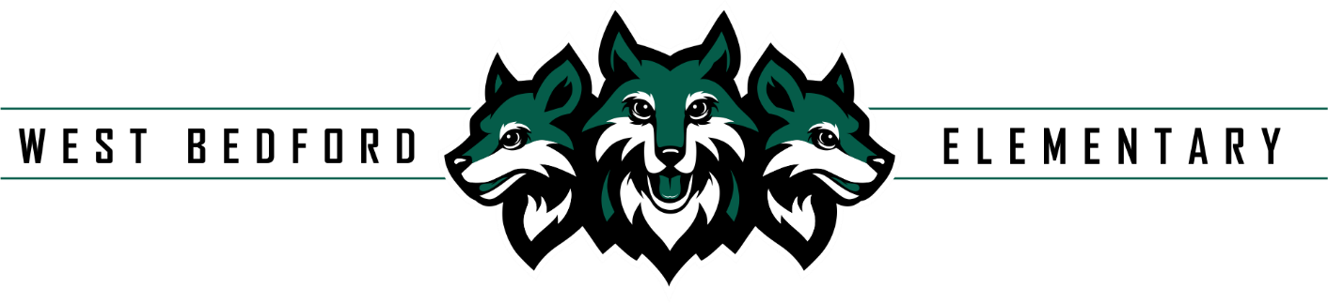
50 Broad Street
Bedford, NS B4A 0T4
902-405-0337, wbs@hrce.ca
Principal: Susan Casey Vice Principals: Courtney Smith
: Joanne Treen

Monday, October 6, 2025

Hello WBS Families,

We have a number of events happening over the month of October. Please take some time to read through this memo.

(Extracurricular) Vivace Choir: Wednesday evenings at WBS-Mixed Voices – Grades 4-7. The anticipated start date is mid-October. Families can register their child(ren) on the HRA Registration Page. Halifax Regional Arts Registration

****It may still say the Hammonds Plains location, the HRA are still waiting on HRCE to change this. ****

HRA Vivace Choir - Mixed Voices 4-7 Free of charge to attend, no audition required
Bikes, Scooters, anything on wheels: We ask that students and adults walk their bike, scooter, anything on wheels while on school property. This is for safety reasons for all students and staff who are outside. We also ask students to leave the bikes and scooters along in the racks during the school day.

School Advisory Council (SAC): We have received many expressions of interest for the two parent/guardian positions so the positions will be filled via an election. The voting period for the SAC positions will be October 6 to October 10, 2025.

Voting Link: https://forms.office.com/r/BhPYtWwfcP

Please choose 2 candidates for the SAC parent/Guardian positions.

2025-2026 WBS Yearbooks are now ON SALE: Pre-orders for the yearbook are on promotion right now for $35 until October 24.



WBH School Fundraiser in partnership with WBS school:

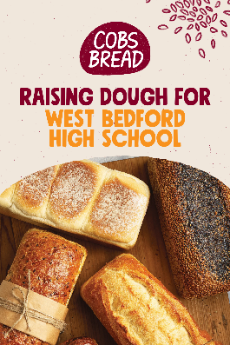
We are excited to partner with WBH on their fundraiser with COBS Bread, Larry Uteck. For every booklet sold by WBS, WBS will share in half the monies with WBH. The fundraiser will be open October 6th to October 17th, 2025.

For just $40, you’ll receive a Bread for a Year voucher booklet with 12 vouchers for FREE loaves of fresh bread (valued at up to $87). Families can redeem one loaf per month at COBS Bread Larry Uteck.

Here’s how it helps WBS:
- Each booklet sold by a WBS student raises $10 directly for our school ($10 will go to WBH). These funds are used to support a wide range of programs and extra-curricular activities.
- Families enjoy healthy, fresh bread at an incredible value.

- It’s simple, practical, and supports both our community and our school.

- Vouchers are valid for a full year and make a wonderful gift for friends, neighbors, and relatives too!

📅 How to purchase: School cash starting Oct. 6th Voucher booklets can be sent home with students.

📍 Where to redeem: COBS Bread, Larry Uteck Plaza - Unit 104, 38 Ella Lane, Bedford

Thank you for supporting our school while enjoying fresh, delicious bread all year long!

Student Demographic Form: PLEASE CHECK YOUR EMAIL- INBOX AND JUNK MAIL! This form needs to be updated as soon as possible. It contains the consent for the use of technology in school (students using IPads and Chromebooks) and a media consent form, which impacts the class photo and yearbook photos. Please note that the form closes on October 6.

WBS Catchment Area: We ask that families follow the HRCE catchment area policy. If you are not living within our catchment area, please let us know so we can support your transfer to your catchment area school. If you have moved, please complete the HRCE address change form:

The 2025-26 HRCE Current Student Change of Address Form
This is the form required if:
- you are moving for the 2025-26 school year and will need to register for a different school within HRCE: or
- you are moving for the 2025-26 school year, but the address is still within the catchment of the current school.
Click here to complete this form.

Safe Arrival Number: If your child is going to be absent for the any part of the school day or arrive late, please call Safe Arrival: 1-833-582-6940. Please note if your child will be late arriving to school you must select that they will be absent for the day. When they arrive our admin team will update their attendance.

Upcoming September Dates
- Monday, September 29th- Professional Learning Day for staff- no school for students; Home and School Pizza Fundraiser with Dominos Pizza
- Tuesday, September 30th -National Day for Truth and Reconciliation- No school for students and staff
Upcoming October Dates
- Grade 6 Provincial Assessments October 6th to 21st 2025
- October 13th- Thanksgiving Day- No School for students and staff
- October 21st- Home & School Meeting 6-7 pm; SAC meeting 7-8 pm
- Home & School Event- BINGO for Books (More information to follow)
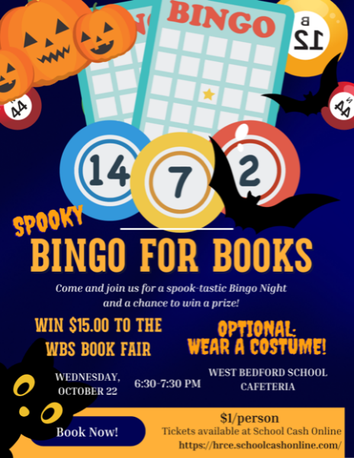
- October 22 and 23 2025- School Picture Days for WBS PP-6
- October 24th- Provincial Conference Day- No school for students

